📘 **Project: SMS Classification (Spam vs Ham)**

**🎯 Objective**

Automatically classify SMS messages as **"spam"** or **"ham"** (non-spam) using:

* **Unsupervised learning** (clustering)
* **Supervised learning** (classification)

**🗂️ 1. Dataset**

* File used: spam.csv
* Selected columns: text (message), target (ham/spam)

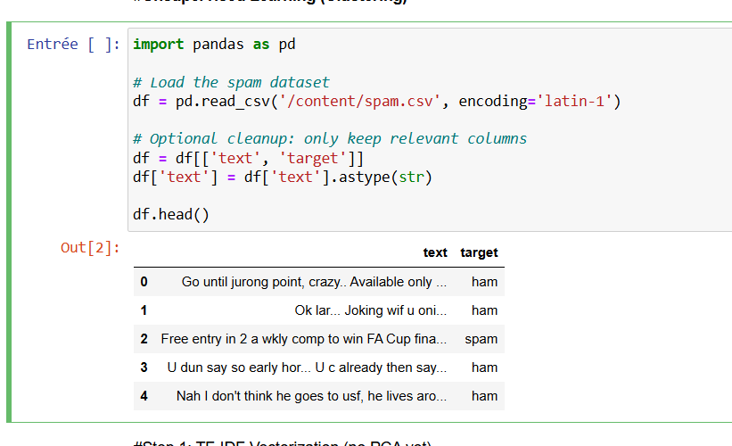

**📌 2. Unsupervised Learning (Clustering)**

**Step 1: TF-IDF Vectorization**

from sklearn.feature_extraction.text import TfidfVectorizer

vectorizer = TfidfVectorizer(stop_words='english', max_features=1000)

X_tfidf = vectorizer.fit_transform(df['text'])

**Step 2: Dimensionality Reduction (PCA)**

from sklearn.decomposition import PCA

pca = PCA(n_components=2)

X_pca = pca.fit_transform(X_tfidf.toarray())

**Step 3: K-Means & Hierarchical Clustering**

from sklearn.cluster import KMeans

from scipy.cluster.hierarchy import linkage, fcluster

# K-Means

kmeans = KMeans(n_clusters=2, random_state=42)

clusters_kmeans = kmeans.fit_predict(X_tfidf)

# Hierarchical

Z = linkage(X_tfidf.toarray(), method='ward')

clusters_hier = fcluster(Z, 2, criterion='maxclust')

**Step 4: Visualization**

import matplotlib.pyplot as plt

# K-Means Clustering

plt.scatter(X_pca[:, 0], X_pca[:, 1], c=clusters_kmeans, cmap='viridis', alpha=0.6)

plt.title("K-means Clustering (TF-IDF + PCA)")

plt.xlabel("PC1")

plt.ylabel("PC2")

plt.show()

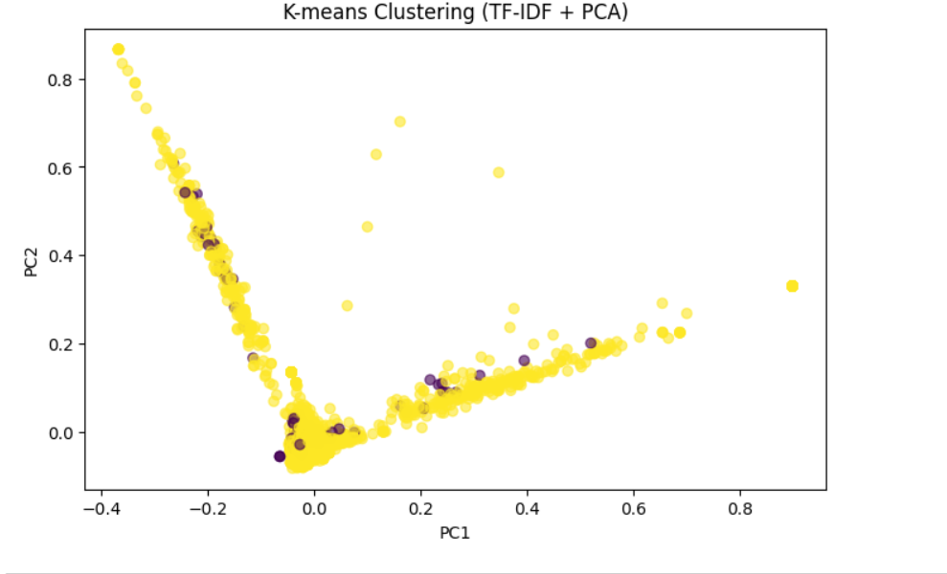

# Ground Truth Labels

label_map = {'ham': 0, 'spam': 1}

labels = df['target'].map(label_map)

plt.scatter(X_pca[:, 0], X_pca[:, 1], c=labels, cmap='coolwarm', alpha=0.6)

plt.title("True Labels (Spam vs Ham)")

plt.xlabel("PC1")

plt.ylabel("PC2")

plt.show()

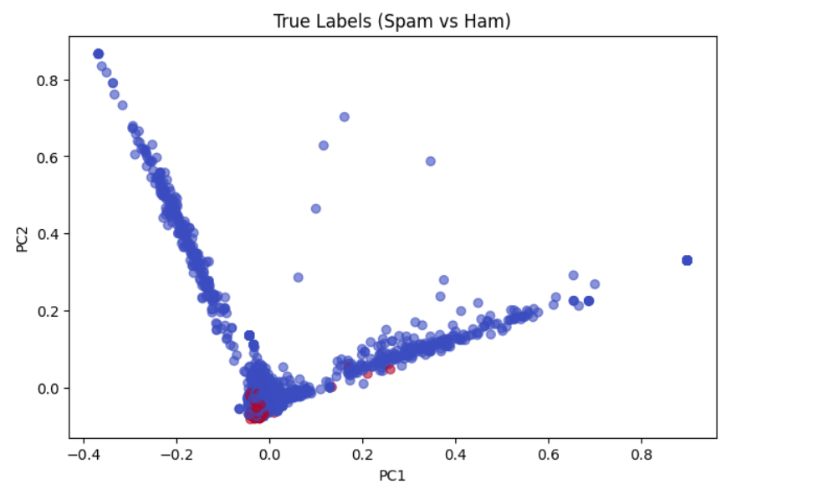

**🧠 3. Supervised Learning (Classification)**

**Step 1: Preprocessing**

from sklearn.model_selection import train_test_split

from sklearn.preprocessing import LabelEncoder

df['label'] = LabelEncoder().fit_transform(df['target']) # ham=0, spam=1

X_train, X_test, y_train, y_test = train_test_split(df['text'], df['label'], test_size=0.2, random_state=42)

**🔤 4. Vectorization with Word2Vec**

**Load Pre-trained Model:**

import gensim.downloader as api

w2v_model = api.load("word2vec-google-news-300")

**Create Document Vectors:**

def document_vector(doc):

doc = doc.lower().split()

return np.mean([w2v_model[w] for w in doc if w in w2v_model], axis=0)

X_train_vec = np.vstack([document_vector(doc) for doc in X_train])

X_test_vec = np.vstack([document_vector(doc) for doc in X_test])

**🔍 5. Classification Models and Results**

**🔸 A. Random Forest**

from sklearn.ensemble import RandomForestClassifier

from sklearn.metrics import classification_report

rf = RandomForestClassifier(n_estimators=100, random_state=42)

rf.fit(X_train_vec, y_train)

y_pred_rf = rf.predict(X_test_vec)

print(classification_report(y_test, y_pred_rf, target_names=['ham', 'spam']))

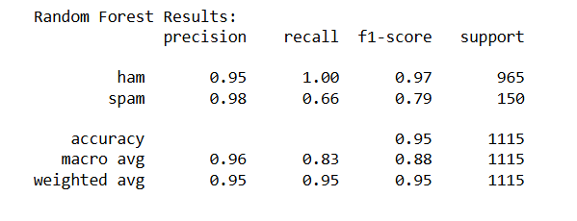

**🔸 B. XGBoost**

import xgboost as xgb

xgb_model = xgb.XGBClassifier(use_label_encoder=False, eval_metric='logloss')

xgb_model.fit(X_train_vec, y_train)

y_pred_xgb = xgb_model.predict(X_test_vec)

print(classification_report(y_test, y_pred_xgb, target_names=['ham', 'spam']))

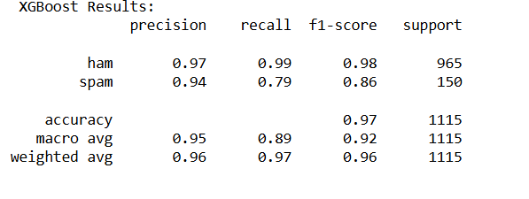

**🔸 C. Naive Bayes (TF-IDF Vector Needed)**

from sklearn.naive_bayes import GaussianNB

nb = GaussianNB()

nb.fit(X_train_vec, y_train)

y_pred_nb = nb.predict(X_test_vec)

print(classification_report(y_test, y_pred_nb, target_names=['ham', 'spam']))

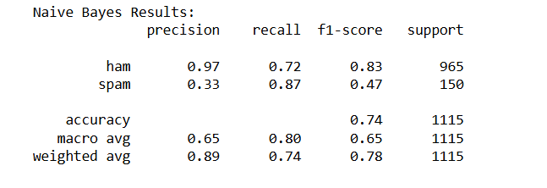

**📊 6. Confusion Matrix**

from sklearn.metrics import confusion_matrix, ConfusionMatrixDisplay

cm = confusion_matrix(y_test, y_pred_rf)

disp = ConfusionMatrixDisplay(confusion_matrix=cm, display_labels=['ham', 'spam'])

disp.plot(cmap='Blues')

plt.title("Random Forest Confusion Matrix")

plt.show()

| **Model** | **Accuracy** | **Recall (Spam)** | **F1-score (Spam)** |
| --- | --- | --- | --- |
| **RandomForest** | 0.95 | 0.66 | 0.79 |
| **XGBoost** | 0.97 | 0.86 | 0.86 |
| **Naive Bayes** | 0.65 | 0.87 | 0.47 |

